Q1. What is an operating system?

Ans. An operating system is system software that manages computer hardware, software resources, and provides common services for computer programs.

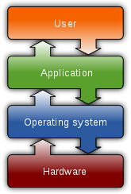

Q2. Types of OS?

Ans. Following are some of the most widely used types of Operating system.

1. Simple Batch System
2. Multiprogramming Batch System
3. Multiprocessor System
4. Desktop System
5. Distributed Operating System
6. Clustered System
7. Realtime Operating System
8. Handheld System

1.Simple Batch Systems

* In this type of system, there is **no direct interaction between user and the computer**.
* The user has to submit a job (written on cards or tape) to a computer operator.
* Then computer operator places a batch of several jobs on an input device.
* Jobs are batched together by type of languages and requirement.
* Then a special program, the monitor, manages the execution of each program in the batch.
* The monitor is always in the main memory and available for execution.

Advantages of Simple Batch Systems

1. No interaction between user and computer.
2. No mechanism to prioritise the processes.

2. Multiprogramming Batch Systems

* In this the operating system picks up and begins to execute one of the jobs from memory.
* Once this job needs an I/O operation operating system switches to another job (CPU and OS always busy).
* Jobs in the memory are always less than the number of jobs on disk(Job Pool).
* If several jobs are ready to run at the same time, then the system chooses which one to run through the process of **CPU Scheduling**.
* In Non-multiprogrammed system, there are moments when CPU sits idle and does not do any work.
* In Multiprogramming system, CPU will never be idle and keeps on processing.

**Time Sharing Systems** are very similar to Multiprogramming batch systems. In fact time sharing systems are an extension of multiprogramming systems.

In Time sharing systems the prime focus is on **minimizing the response time**, while in multiprogramming the prime focus is to maximize the CPU usage.

3.Multiprocessor Systems

A Multiprocessor system consists of several processors that share a common physical memory. Multiprocessor system provides higher computing power and speed. In multiprocessor system all processors operate under single operating system. Multiplicity of the processors and how they do act together are transparent to the others.

Advantages of Multiprocessor Systems

1. Enhanced performance
2. Execution of several tasks by different processors concurrently, increases the system's throughput without speeding up the execution of a single task.
3. If possible, system divides task into many subtasks and then these subtasks can be executed in parallel in different processors. Thereby speeding up the execution of single tasks.

## 4.Desktop Systems

Earlier, CPUs and PCs lacked the features needed to protect an operating system from user programs. PC operating systems therefore were neither **multiuser** nor **multitasking**. However, the goals of these operating systems have changed with time; instead of maximizing CPU and peripheral utilization, the systems opt for maximizing user convenience and responsiveness. These systems are called **Desktop Systems** and include PCs running Microsoft Windows and the Apple Macintosh. Operating systems for these computers have benefited in several ways from the development of operating systems for **mainframes**.

**Microcomputers** were immediately able to adopt some of the technology developed for larger operating systems. On the other hand, the hardware costs for microcomputers are sufficiently **low** that individuals have sole use of the computer, and CPU utilization is no longer a prime concern. Thus, some of the design decisions made in operating systems for mainframes may not be appropriate for smaller systems.

5.Distributed Operating System

The motivation behind developing distributed operating systems is the availability of powerful and inexpensive microprocessors and advances in communication technology.

These advancements in technology have made it possible to design and develop distributed systems comprising of many computers that are inter connected by communication networks. The main benefit of distributed systems is its low price/performance ratio.

Advantages Distributed Operating System

1. As there are multiple systems involved, user at one site can utilize the resources of systems at other sites for resource-intensive tasks.
2. Fast processing.
3. Less load on the Host Machine.

### Types of Distributed Operating Systems

Following are the two types of distributed operating systems used:

1. Client-Server Systems
2. Peer-to-Peer Systems

6.Clustered Systems

* Like parallel systems, clustered systems gather together multiple CPUs to accomplish computational work.
* Clustered systems differ from parallel systems, however, in that they are composed of two or more individual systems coupled together.
* The definition of the term clustered is **not concrete;** the general accepted definition is that clustered computers share storage and are closely linked via LAN networking.
* Clustering is usually performed to provide **high availability**.
* **Asymmetric Clustering -** In this, one machine is in hot standby mode while the other is running the applications. The hot standby host (machine) does nothing but monitor the active server. If that server fails, the hot standby host becomes the active server.
* **Symmetric Clustering -** In this, two or more hosts are running applications, and they are monitoring each other. This mode is obviously more efficient, as it uses all of the available hardware.
* **Parallel Clustering -** Parallel clusters allow multiple hosts to access the same data on the shared storage. Because most operating systems lack support for this simultaneous data access by multiple hosts, parallel clusters are usually accomplished by special versions of software and special releases of applications.

## 7.Real Time Operating System

It is defined as an operating system known to give maximum time for each of the critical operations that it performs, like OS calls and interrupt handling.

The Real-Time Operating system which guarantees the maximum time for critical operations and complete them on time are referred to as **Hard Real-Time Operating Systems.**

While the real-time operating systems that can only guarantee a maximum of the time, i.e. the critical task will get priority over other tasks, but no assurity of completeing it in a defined time. These systems are referred to as **Soft Real-Time Operating Systems**.

## 8.Handheld Systems

Handheld systems include **Personal Digital Assistants(PDAs)**, such as Palm-Pilots or Cellular Telephones with connectivity to a network such as the Internet. They are usually of limited size due to which most handheld devices have a small amount of memory, include slow processors, and feature small display screens.

Many handheld devices have between **512 KB** and **8 MB** of memory. As a result, the operating system and applications must manage memory efficiently.

Currently, many handheld devices do **not use virtual memory** techniques, thus forcing program developers to work within the confines of limited physical memory.

Q3. Features of Operating System?

**Features of Operating System**

Here is a list commonly found important features of an Operating System:

* Protected and supervisor mode
* Allows disk access and file systems Device drivers Networking Security
* Program Execution
* Memory management Virtual Memory Multitasking
* Handling I/O operations
* Manipulation of the file system
* Error Detection and handling
* Resource allocation
* Information and Resource Protection

Q4. Linux Architecture with diagram?

### Linux System Architecture

The Linux Operating System’s architecture primarily has these components: the Kernel, Hardware layer, System library, Shell and System utility.

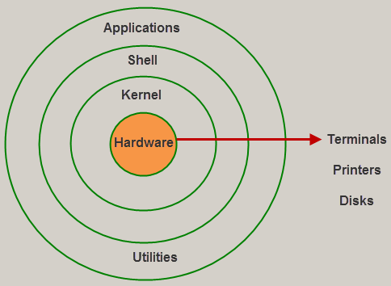

Architecture of Linux

1. The kernel is the core part of the operating system, which is  responsible for all the major activities of the LINUX operating system. This operating system consists of [different modules](https://www.elprocus.com/different-types-of-memory-modules-used-embedded-system/) and interacts directly with the underlying hardware. The kernel offers the required abstraction to hide  application programs or low-level hardware details to the system.
2. System libraries are special functions, that are used to implement the functionality of the operating system and do not require code access rights of kernel modules.
3. System Utility programs are liable to do individual, and specialized-level tasks.
4. Hardware layer of the LINUX operating system consists of peripheral devices such as RAM, HDD, CPU.
5. The shell is an interface between the user and the kernel, and it affords services of the kernel. It takes commands from the user and executes kernel’s functions. The Shell is present in different types of operating systems, which are classified into two types:command line shells and graphical shells.

Q5. Explain Shell and kernel with example?

1. The kernel is the central component of a computer operating systems. The only job performed by the kernel is to the manage the communication between the software and the hardware. A Kernel is at the nucleus of a computer. It makes the communication between the hardware and software possible. While the Kernel is the innermost part of an operating system, a shell is the outermost one.

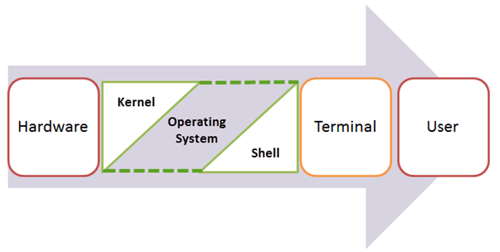

## Features of Kennel

* Low-level scheduling of processes
* Inter-process communication
* Process synchronization
* Context switching

### Types of Kernels

There are many types of kernels that exists, but among them, the two most popular kernels are:

1**.Monolithic**

A monolithic kernel is a single code or block of the program. It provides all the required services offered by the operating system. It is a simplistic design which creates a distinct communication layer between the hardware and software.

**2. Microkernels**

Microkernel manages all system resources. In this type of kernel, services are implemented in different address space. The user services are stored in user address space, and kernel services are stored under kernel address space. So, it helps to reduce the size of both the kernel and operating system.

1. Shell :

The shell is an interface between the user and the kernel, and it affords services of the kernel. It takes commands from the user and executes kernel’s functions. The Shell is present in different types of operating systems, which are classified into two types:command line shells and graphical shells.

The command line shells provide a command line interface, while the graphical line shells provide a graphical user interface. Though both shells perform operations, but the graphical user interface shells perform slower than the command line interface shells. Types of shells are classified into four:

* Korn shell
* Bourne shell
* C shell
* POSIX shell

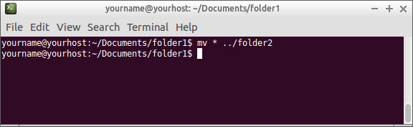

Q.6 command lines .

